Dear Villagers,

We have been delighted to welcome all of the children back to school on March 8th, after a long period of lockdown since January, where only key workers children were able to attend. It has been fabulous to see everyone so happy to be back in school, chatting with their friends. There is a real buzz about the place again! During the lockdown, along with all of the remote learning that took place , the children created a fabulous Art in the Heart project which you may like to see – here :- https://padlet.com/acressingham/Sandringham_Federation.

This week we have been able to go back to church for the first time in ages for our Palm Sunday service, although no singing was allowed yet, but the children enjoyed receiving their palm crosses from Father Jonathan. It feels a little strange to be breaking up for Easter, as we have only been back in school for 3 weeks, but I know everyone is looking forward to their holiday.

We have also been able to enjoy our forest schools’ lessons again and we are especially grateful to Lady Dawnay of the Hillington Estate, for allowing the school to use the woodland. Here they are amongst the beautiful snowdrops.

We would also like to say that we have space in our Nursery Class for 3-year-olds from now and in September, so if you are looking for a lovely nursery in a beautiful setting, please do give the school office a call to arrange a visit on 01485 600383.
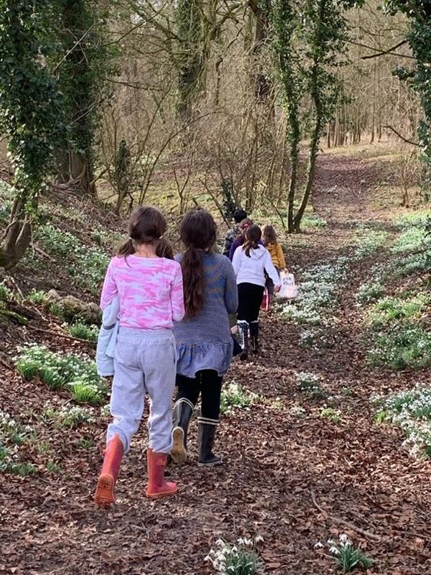

Mrs Gardener March 23rd 2021

